Audience Need

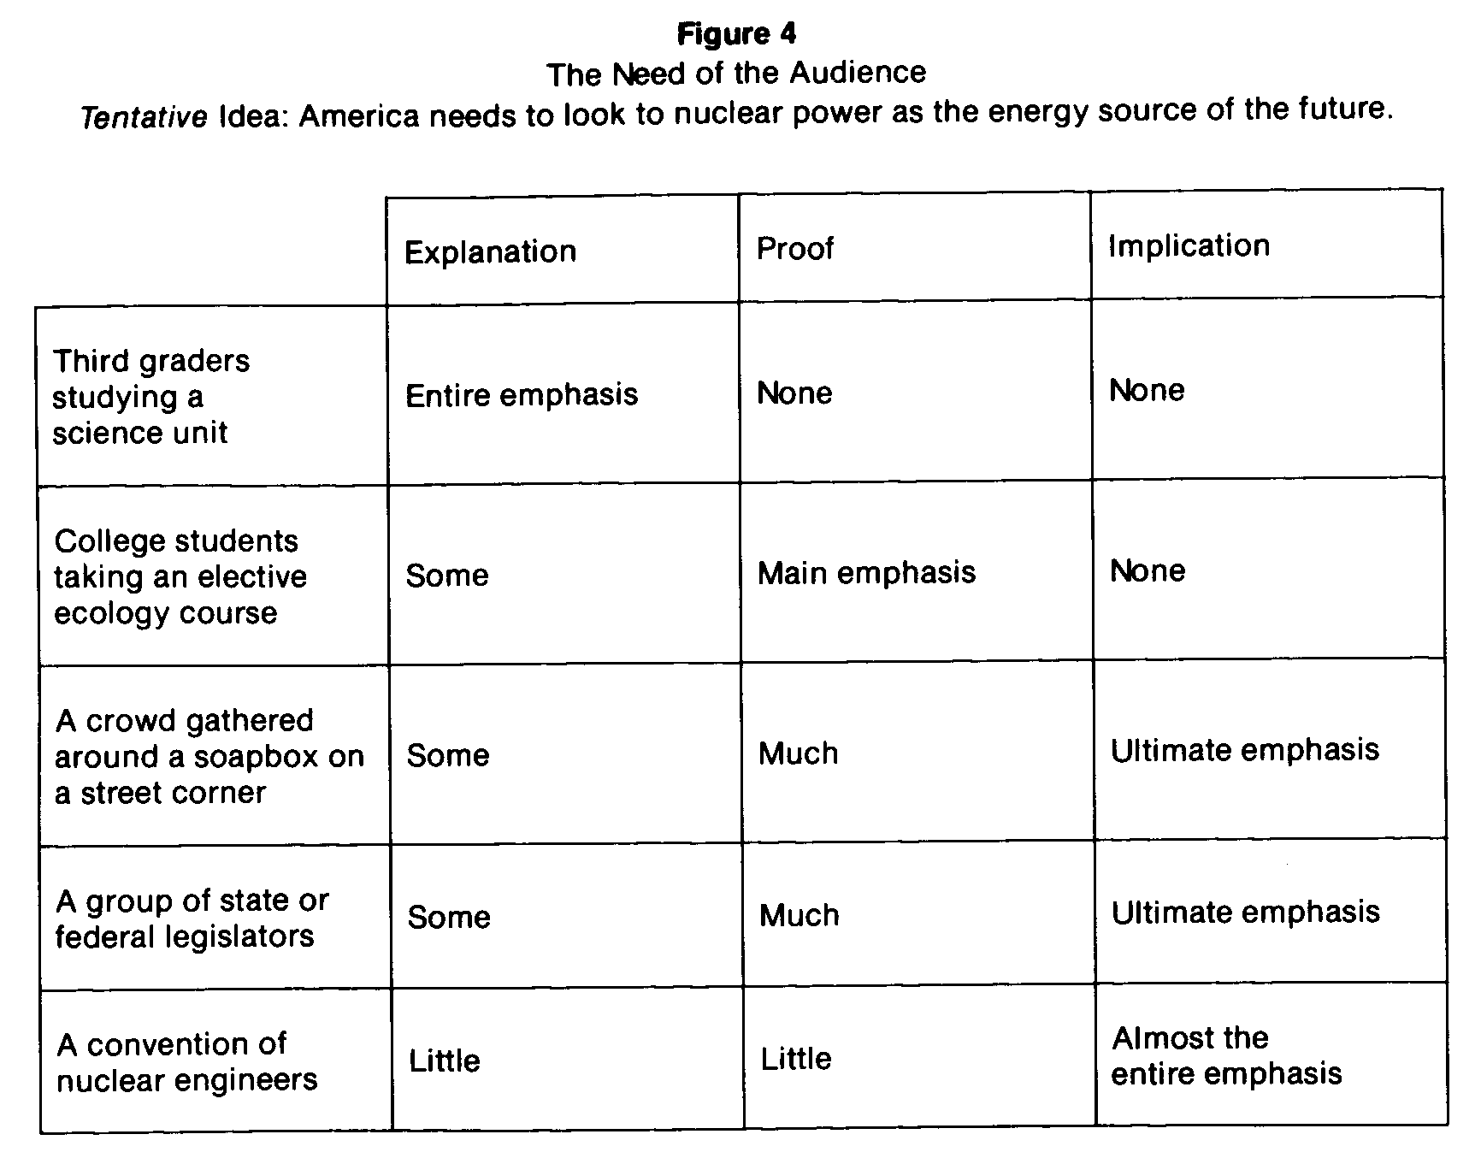
It is not difficult to see that the need you must address can be
discovered only in the light of both the subject matter and the
audience. Thus the first step toward determining a clear purpose
for your speech is to weigh the idea you have chosen and the
audience you will address, and then to decide which of the three
types of material will dominate your message: explanation, proof,
or implication. If your answer is explanation, then your speech
probably will not include much proof or motivational material.
You have decided that what your audience needs is information
about your subject, and the speech will be designed to communi-
cate it to them in a clear, interesting, and orderly fashion. If your
answer is proof then your speech may or may not include
substantial amounts of explanatory material, depending on how
well your audience understands your subject. What is certain,
though, is that whatever information you present will be basically
a necessary preliminary to the primary thrust of your speech,
which lies in the realm of proof. If your answer is implication,
then your speech may or may not deal with explanation and
proof, depending upon the requirements of the audience. But if
it includes explanation and proof, both of these will function
primarily as means to demonstrating the implications of your
idea for the behavior of your audience.

Step Two: The Desired Response

The second step toward coming up with a purpose for your
speech is to decide upon what response you desire from your
audience. This is not something separate from the considera-
tion ofyour audience’s need, but in fact is the natural outgrowth
of it. The response you desire from your audience can be
expressed through the use of infinitives which correspond to the
three categories of need: “I want my audience to understand
how (explanation); “I want my audience to believe that...”
(proof); “I want my audience to behave fin some particular way!’
(implication).
It would not be an overstatement to say that the main idea of
this whole section is that you should always be seeking some
response from your audience. Indeed, the pitfall of pedantry lies
just here: the pedant merely goes through the motions without
any thought of what response he seeks from his audience. But
this is an oversight you cannot afford ifyou want to be an effective
communicator. You must always attempt to elicit a response of
some sort from your audience, and it is always helpful to pin
down just what that response is to be.
Figure 5 is a chart of potential responses a speaker might seek
from several of the audiences we have examined. The tentative
statement of the speech idea is: ‘America needs to look to nuclear
power as the energy source of the future.” (Notice that the
speaker’s preliminary statement of the idea, as it stands, is already
inadequate for all but the college audience; and even here it will
probably have to be softened to something like: ‘America should
look to nuclear power as one useful energy source for the future.”

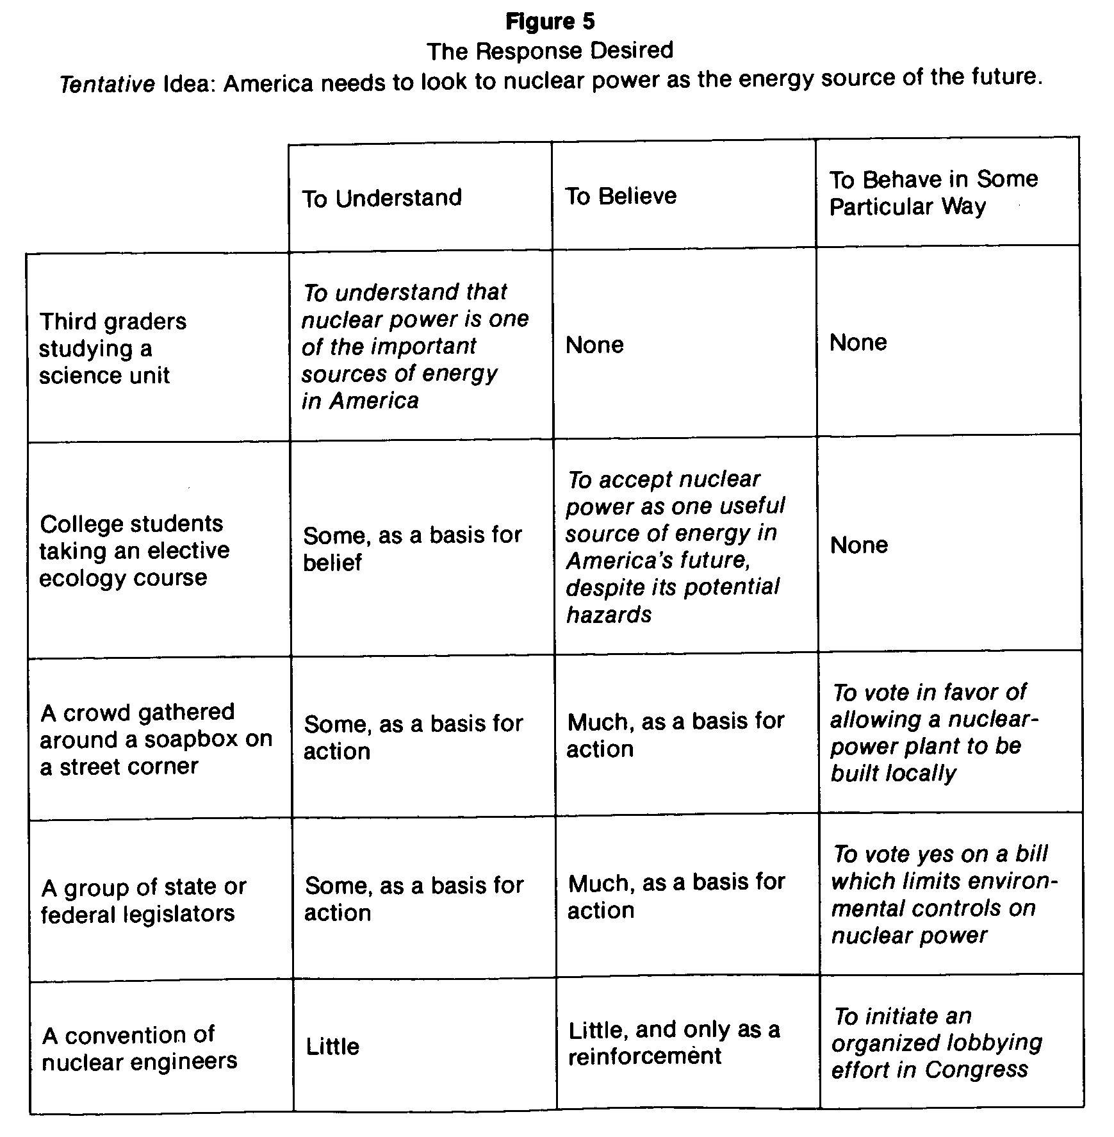
We will deal with the matter of reformulating the statement of the
speech idea later in this chapter

Step Three: Wording the Purpose of the Speech

The third step is to put into words the purpose of the speech.
Having focused upon the audience’s need, and from that, having
pinned down the response that you desire to elicit from them,
you are now prepared to articulate in a single, clear, concise
sentence what you hope to accomplish through the speech. Like
the statement of the desired response, this purpose statement
will usually be built around one of three infinitives which corre-
spond to the three categories of need: ‘My purpose is to inform
my audience how (explanation); “My purpose is to persuade
my audience that (proof); “My purpose is to motivate my
audience to behave [in some particular way] “(implication).

The Thre

The three types of purposes we have examined correspond to
the three primary types of speeches: (1) ~the informative speech,
(2) the persuasive speech, (3) thei4iëeäi-io actuate~. But notice
that these purposes are not so much something which you bring
to the situation as they are something that you discover i4ithin
the situation. In a very real sense it is the audience that deter-
mines the purpose of the speech, not you the speaker. Let us look
more closely at each of these three types of speeches.

The Speech to Inform

Informative speeches are common, everyday occurrences. In
business, education, the military, the church, and in many social
settings speeches abound that are designed to accomplish little
more than informing an audience about some particular subject.
The distinguishing mark ofthe informative speech is its limited
objective. The sole purpose of the speech is to clarify, explain,
describe, define, report, or otherwise broaden the audience’s
knowledge about some concept, term, process, relationship, or

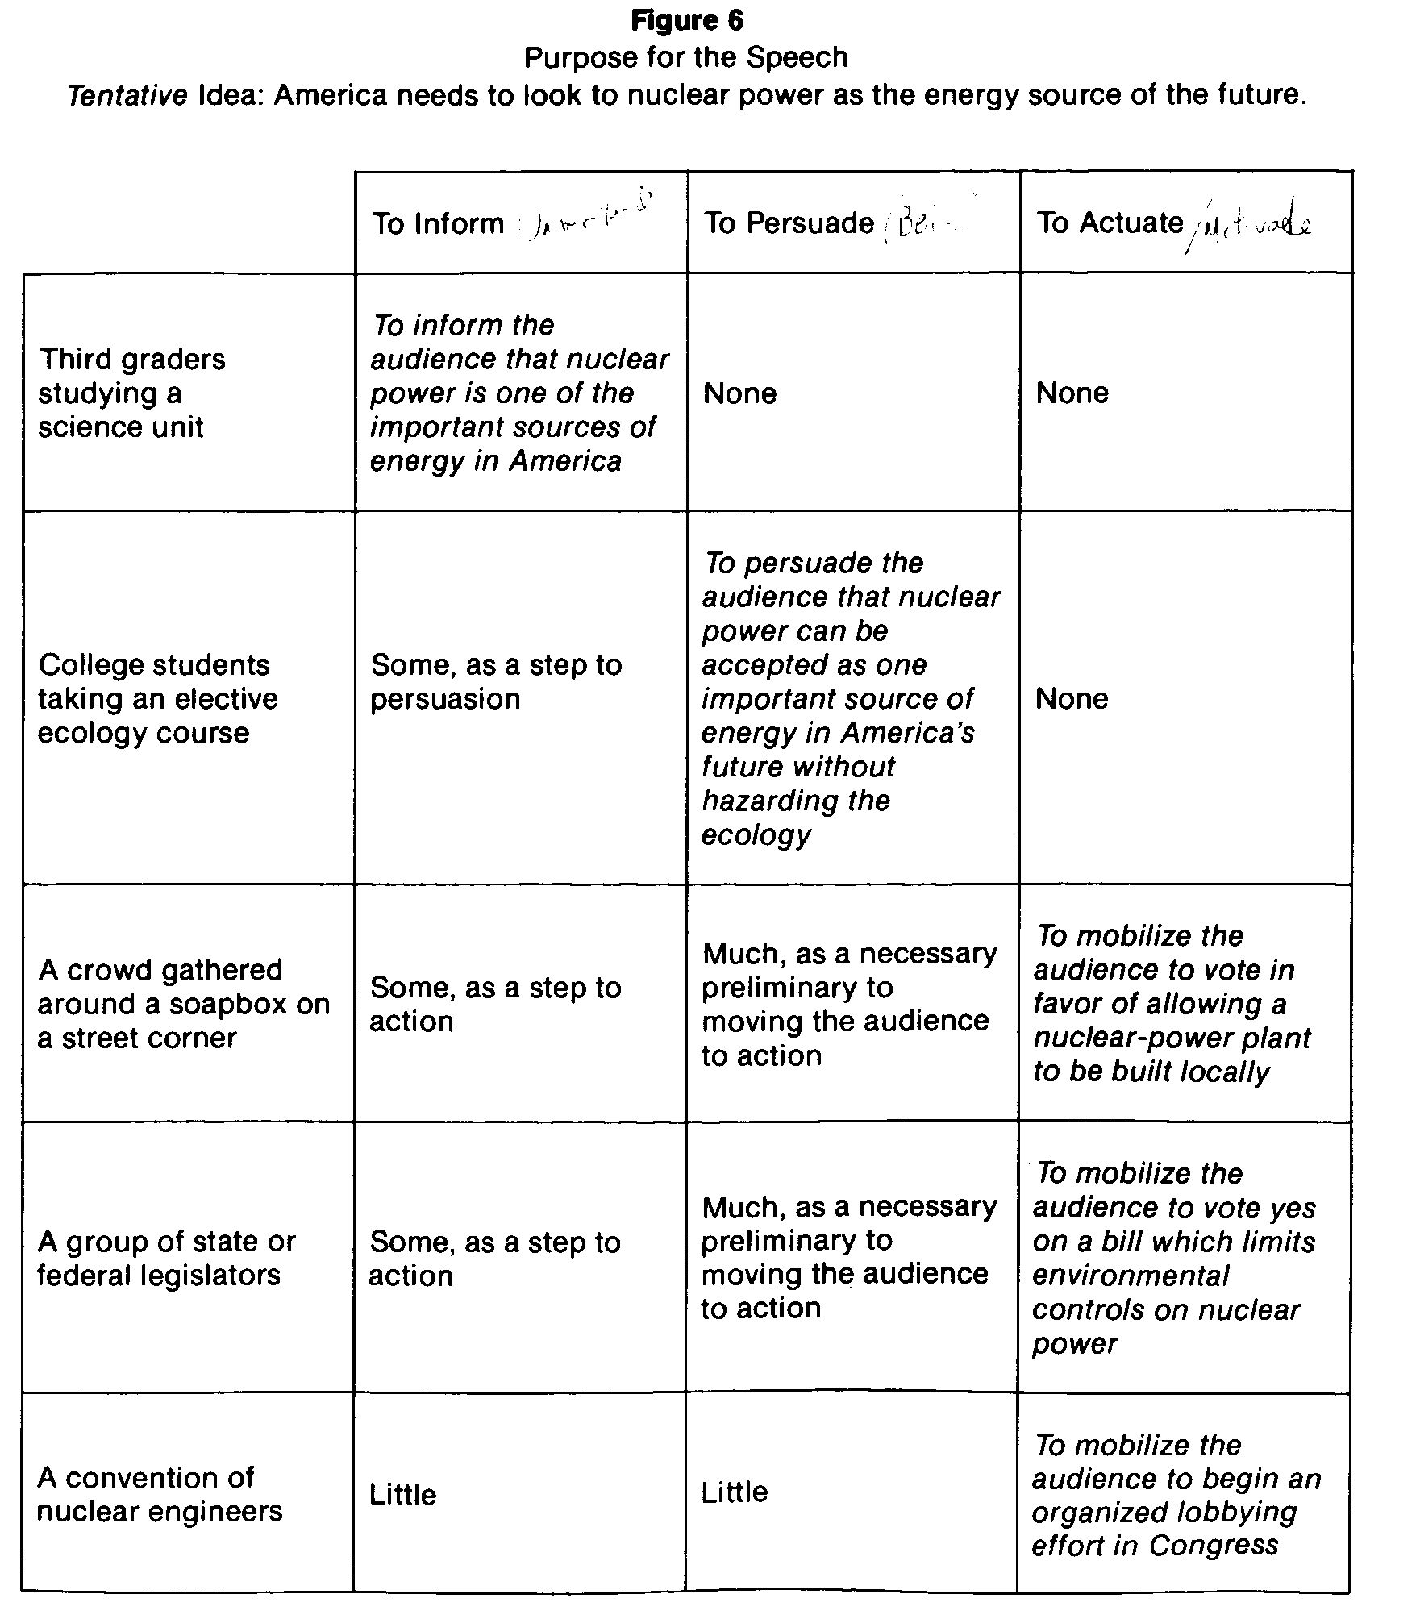
other subject. The speakers goal is simply to enable the audience
to grasp and then retain the material.
Because of the nature of this goal informative speeches consist
largely, if not entirety of factual material. Factual materials are
those which are independently verifiable, such as historical
events, statistics, scientific laws or principles, and other settled,
noncontroversial, demonstrable observations. Hence, by their
very nature informative speeches call for understanding from the
audience, not belief or debate. Your prime responsibilities when
you give an informative speech are to present the material
honestly (separating fact from opinion), completely (not leaving
out pertinent aspects of the subject), clearlyso that the material
can be understood), and accurately (so that the result is not
misleading).
While informative speeches seem simple enough at first glance,
there are several obstacles they must typically hurdle. The first is
the difficulty of being clear. The explanation of a complex process,
relationship, or concept is not easy. You must work to keep the
structure of the message simple. This can be accomplished by
(1) limiting the number of major points in the structure of the
outline; (2) keeping the transitions clear; (3) including abundant
internal summaries; (4) using simple, nontechnical language;
(5) defining any ambiguous terms; and (6) making the abstract
concrete through the use of analogies, comparisons, contrasts,
examples, and even visual aids (see chapter 6).
The second major difficulty of the informative speech is the
problem of gaining and holding the attention of the audience.
Factual material in itself is seldom very exciting. Thus informative
speeches can easily become drab and boring. But drabness can
usually be replaced with color by employing (1) vivid language,
(2) concrete and specific illustrations, (3) hypothetical examples,
and (4) human-interest narrative. Each of these should be used in
such a way as to relate the new ideas of the speech to the existing
knowledge of the audience.
The third obstacle for the informative speech is the tendency
of speakers to cover too much material too quickly It is far better
to limit the subject and cover it well than to take on a broader
subject and then swamp the audience with more information
than they can assimilate. The tendency to attempt too much

